# **CLOUD INTRODUCTION**

**Cloud computing:**

Cloud Computing means storing and accessing the data and programs on remote servers that are hosted on the internet instead of the computer’s hard drive or local server.

* On demand service on the internet
* Pay-as-you-go

**Types of cloud:**

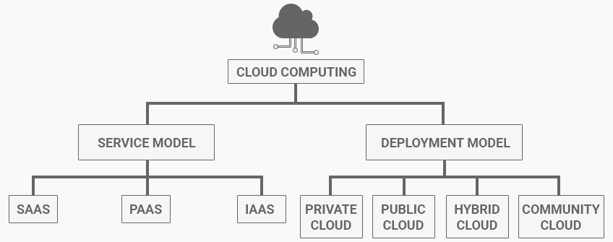

**Deploment models or Types of Cloud Computing:**

**Public Cloud**

* Definition: Services are delivered over the public internet and shared across multiple organizations.
* Examples: Amazon Web Services (AWS), Microsoft Azure, Google Cloud Platform (GCP).
* Advantages: Cost-effective, scalable, and easy to set up.
* Disadvantages: Less control over security and compliance.

**Private Cloud**

* Definition: Services are maintained on a private network and used exclusively by a single organization.
* Examples: VMware, OpenStack.
* Advantages: Enhanced security, greater control, and customization.
* Disadvantages: Higher costs and complexity in setup and maintenance.

**Hybrid Cloud**

* Definition: Combines public and private clouds, allowing data and applications to be shared between them.
* Examples: IBM Hybrid Cloud, Microsoft Azure Stack.
* Advantages: Flexibility, optimized workload management, and cost efficiency.
* Disadvantages: Complex management and potential security risks.

**Community Cloud**

* Definition: Shared infrastructure for a specific community with common concerns (e.g., security, compliance).
* Examples: Government agencies, healthcare organizations.
* Advantages: Cost-sharing, enhanced security, and compliance.
* Disadvantages: Limited scalability and potential for conflicts among community members.

**Cloud Service Models**

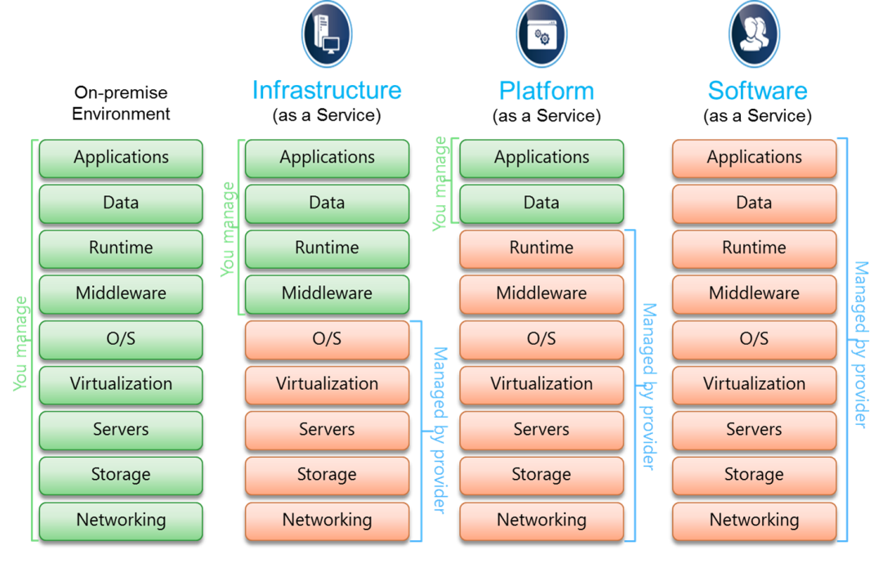

**Infrastructure as a Service (IaaS)**

* Definition: Provides virtualized computing resources over the internet.
* Examples: AWS EC2, Google Compute Engine, Microsoft Azure VMs.
* Advantages: High flexibility, pay-as-you-go pricing, and control over infrastructure.
* Disadvantages: Requires management of the operating system and applications

**Platform as a Service (PaaS)**

* Definition: Provides a platform allowing customers to develop, run, and manage applications without dealing with the underlying infrastructure.
* Examples: Google App Engine, Microsoft Azure App Services, Heroku.
* Advantages: Simplifies development, reduces management overhead, and supports multiple programming languages.
* Disadvantages: Less control over the underlying infrastructure and potential vendor lock-in.

**Software as a Service (SaaS)**

* Definition: Delivers software applications over the internet, on a subscription basis.
* Examples: Google Workspace, Microsoft Office 365, Salesforce.
* Advantages: Easy to use, no need for installation or maintenance, and accessible from anywhere.
* Disadvantages: Limited customization and potential data security concerns.

**Benefits of Cloud Computing**

* Cost Efficiency: Reduces capital expenditure on hardware and software.
* Scalability: Easily scales resources up or down based on demand.
* Accessibility: Access services from anywhere with an internet connection.
* Disaster Recovery: Provides robust backup and recovery solutions.
* Collaboration: Enhances team collaboration through shared resources and tools.

**Challenges of Cloud Computing**

* Security: Concerns over data breaches and unauthorized access.
* Compliance: Meeting regulatory requirements can be complex.
* Downtime: Potential for service outages and downtime.
* Vendor Lock-In: Difficulty in migrating from one provider to another.
* Cost Management: Uncontrolled usage can lead to unexpected costs.

Key Players in Cloud Computing

1. Amazon Web Services (AWS): Leading provider with a wide range of services.
2. Microsoft Azure: Strong enterprise presence and integration with Microsoft products.
3. Google Cloud Platform (GCP): Known for its data analytics and machine learning capabilities.
4. IBM Cloud: Focuses on hybrid cloud and AI solutions.
5. Oracle Cloud: Specializes in enterprise applications and databases.